**Lab Assignment 7**

This is an application developed using Ionic framework which has Registration and Login functionalities. It has ionic plugins like firebase plugin for login and registration OAuth plugin for facebook login, Bar code scanner plugin which scan s a particular product and gives the product id and Speech Recognition plugin which converts text- to-speech and speech-to-text.

**Wire Frames:**

**Login Page:**

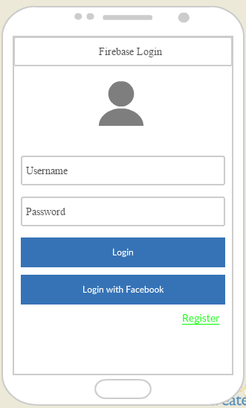

**Login Failure Page:**

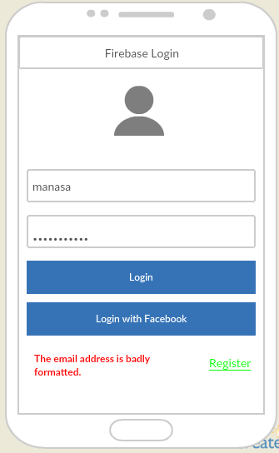

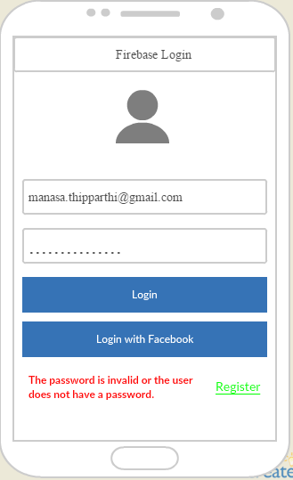

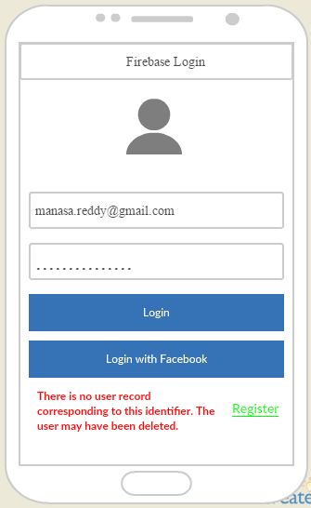

**Registration Page:**

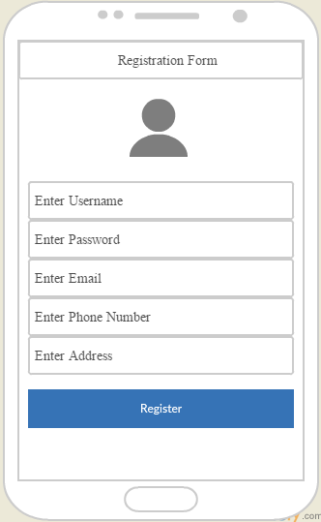

**Registration Success Page:**

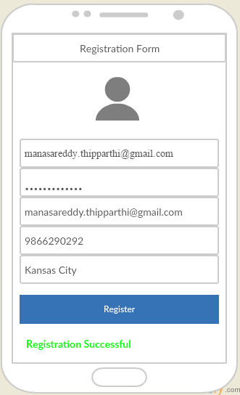

**Registration Failure Page:**

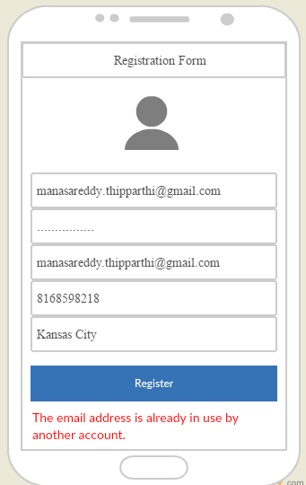

**Welcome Page:**

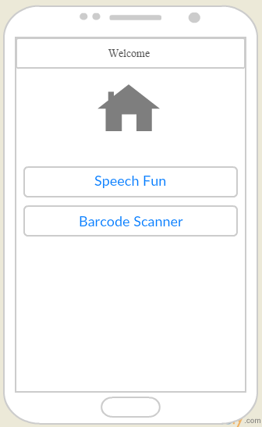

**Speech Recognition Page:**

**Speech to Text Conversion Page:**

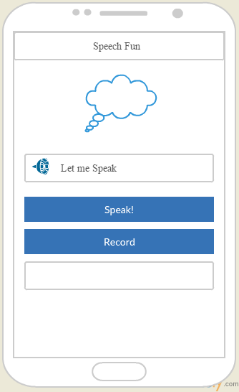

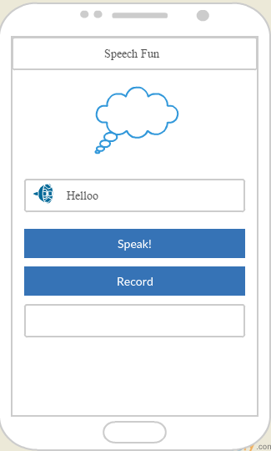

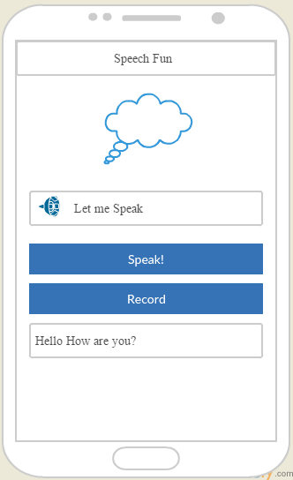

**Barcode Scanner Page:**

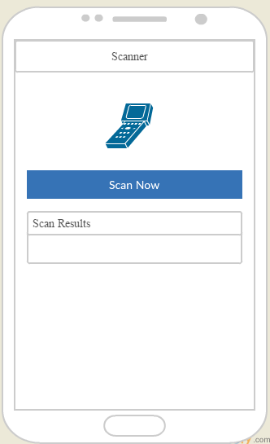

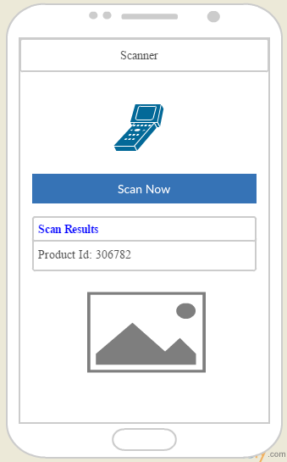

**Web Application Pages:**

**Login Page:**

This is the Login page of the Web Application. This page contains two text fields to enter Username and Password. If you enter valid credentials and then click “Login” button it will direct to the Home page. It uses firebase ionic plugin to validate the credentials. If you click on Register Link it will direct to the Registration page.

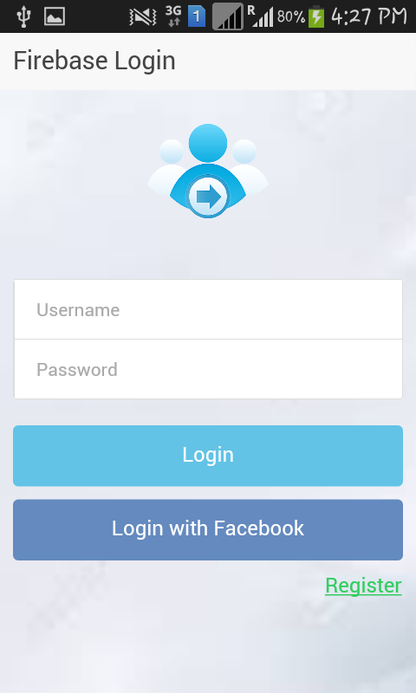

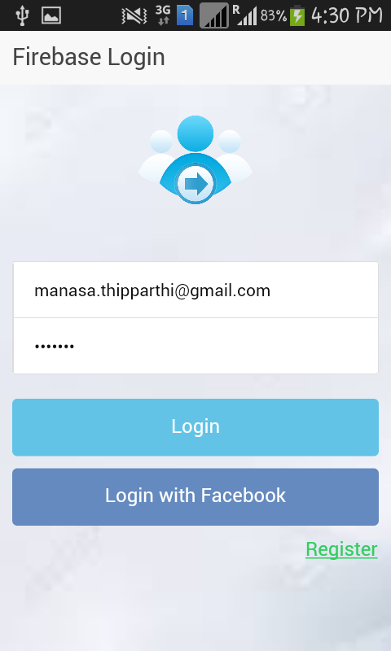

**Login Failure Page:**

If you enter Invalid credentials and try to login It will direct to the Login Page and Display a message stating that the credentials are invalid. The failure can be due to wrong password or due to incorrect email format etc.

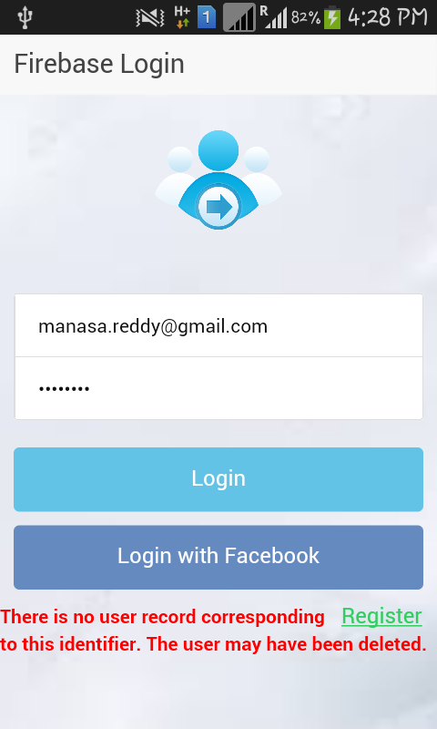

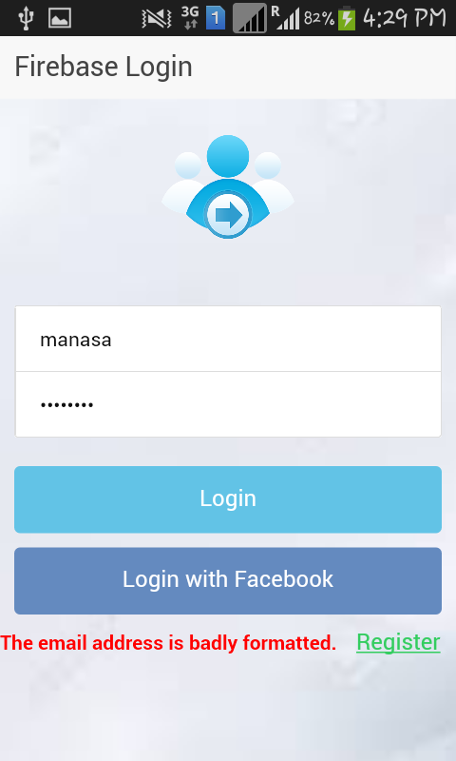

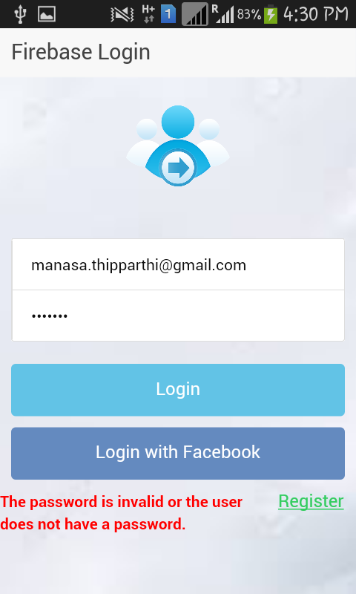

**Registration Page:**

If you are logging in for the first time if you click on register link in the Login Page it will get directed to the Registration Page. You have all your basic details and then click “Register”. If you want to cancel the Registration then click on “Cancel” lick which will direct to the Login Page. This uses firebase plugin to register the email id. If already the email is registered it will show the error message.

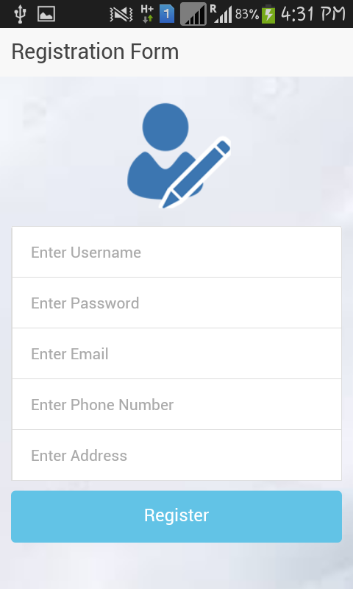

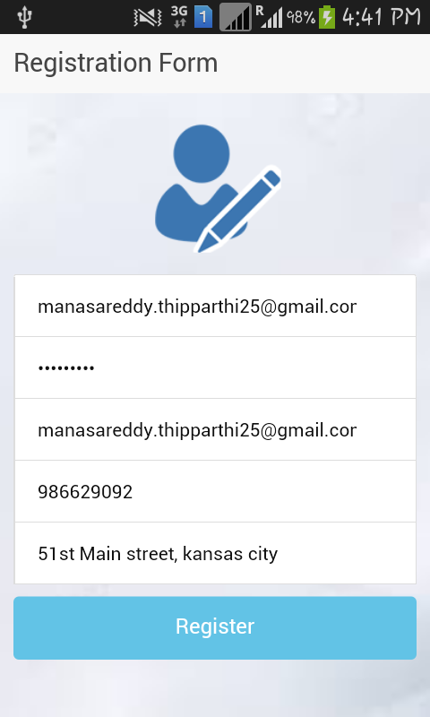

**Registration Success page:**

If you enter all the details and if there is no email in the firebase list then the registration is done successfully. It will direct to the Registration Page and display a message stating that the “Registration Successful”.

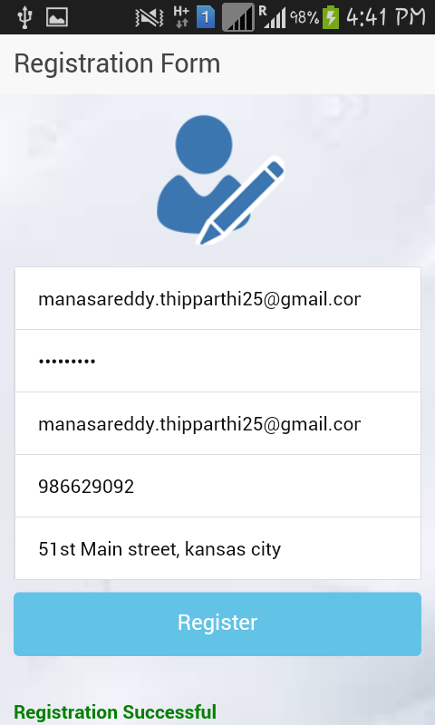

**Registration Failure Page:**

If any user with the email already has registered then your registration could not be done. It then directs to the Registration Page and display a message stating the “email already registered”.

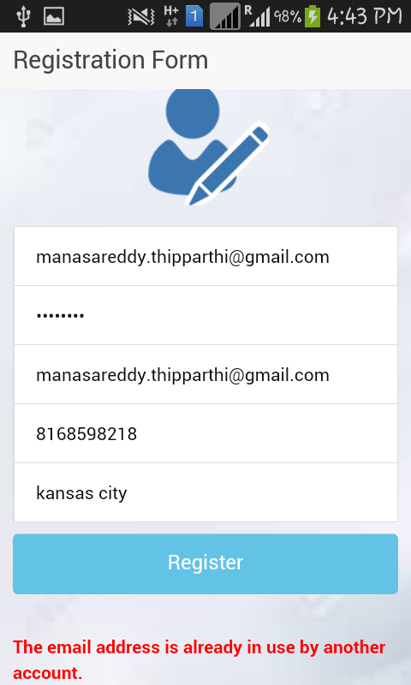

**Home page:**

The Welcome page contains the list of functionalities provided in this application they are barcode scanning and speech recognition which are ionic plugins.

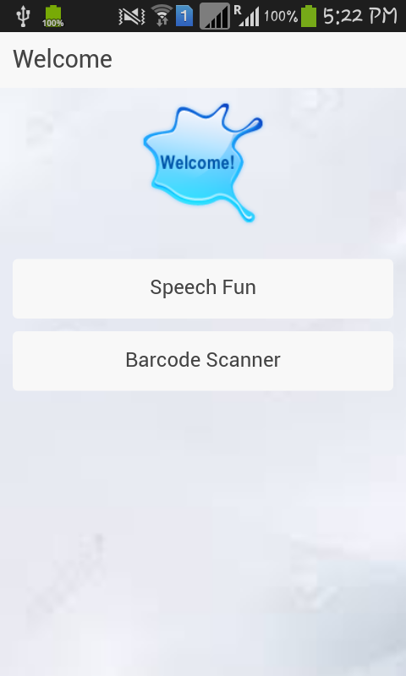

**Speech Recognition page:**

This page contains the functionality to convert from text-to-speech and speech-to-text. Enter the text in let me speak field and press the speak button you can hear the text you have entered. If you to convert speech to text click record button it will start recording and display the result.

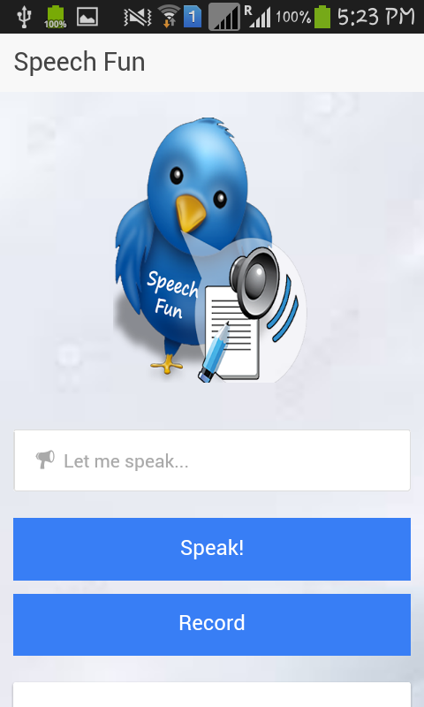

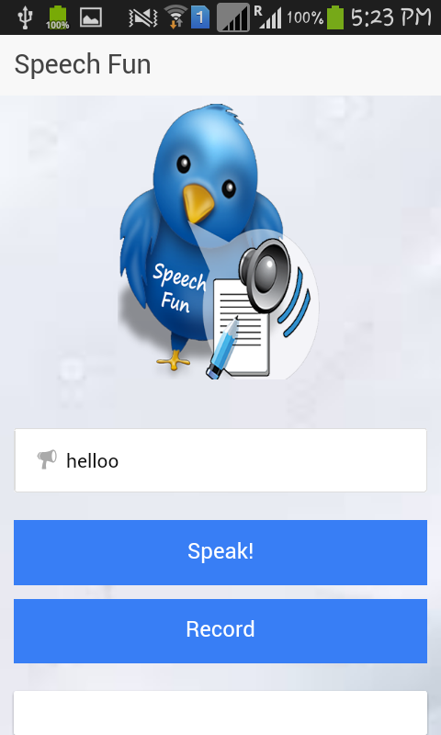

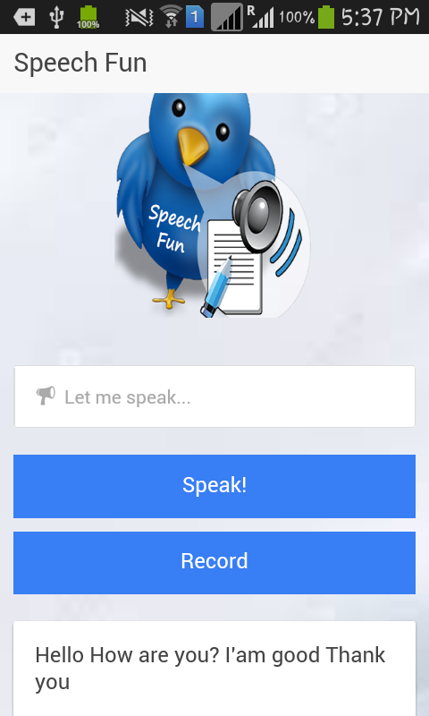

**Barcode Scanner page:**

This page scans the product and displays its particular product id. To scan the product click and scan now then you can scan your product it will be processed and displays the product you have scanned and its id in the result page.

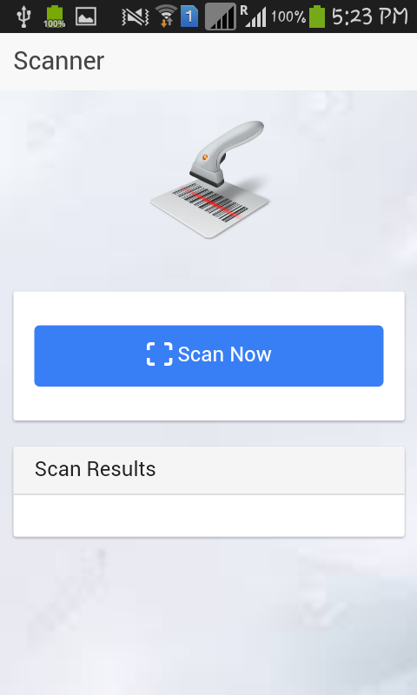

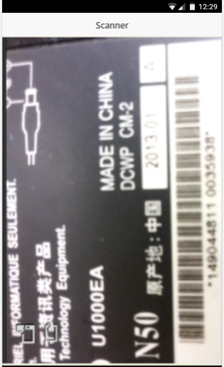

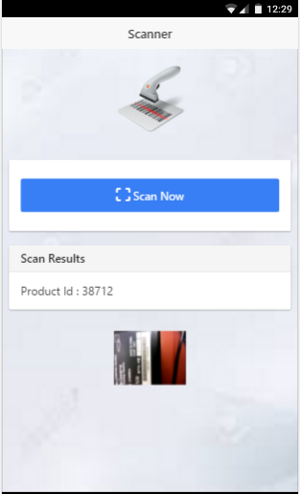

**Y-Slow:**

**Y-Slow Home:**

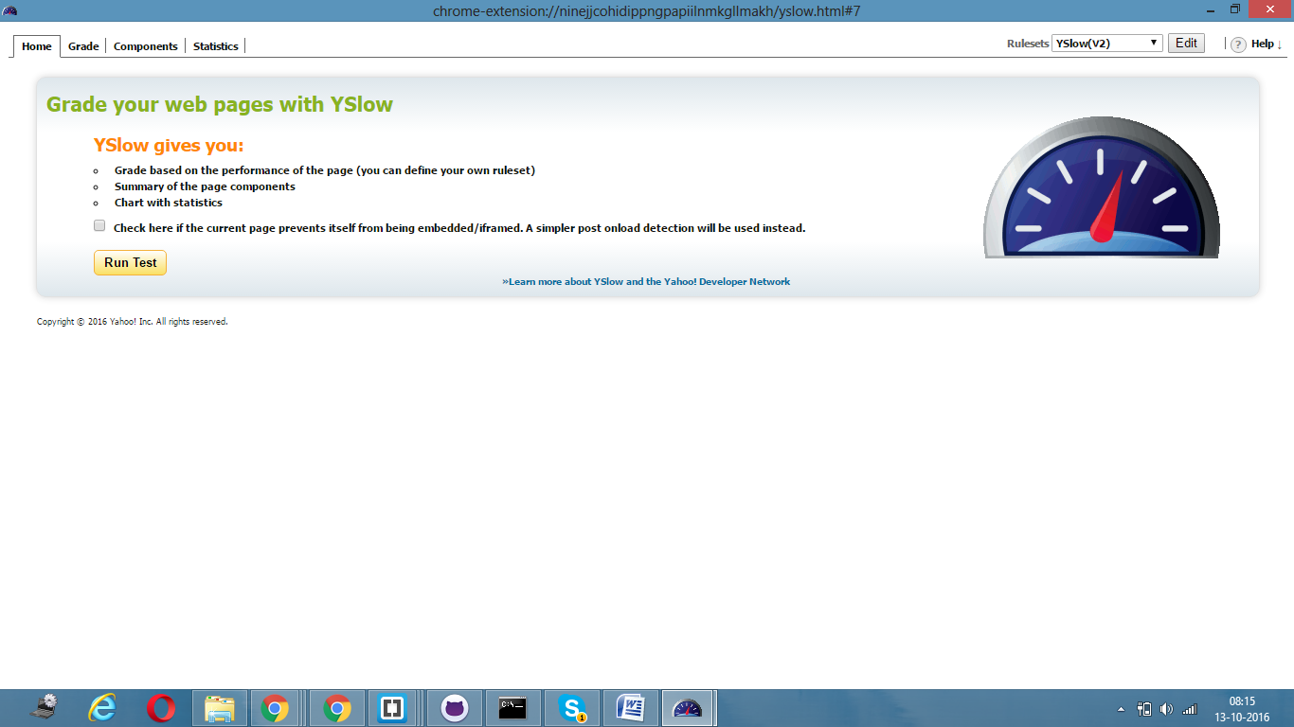

**Y-Slow Grade:**

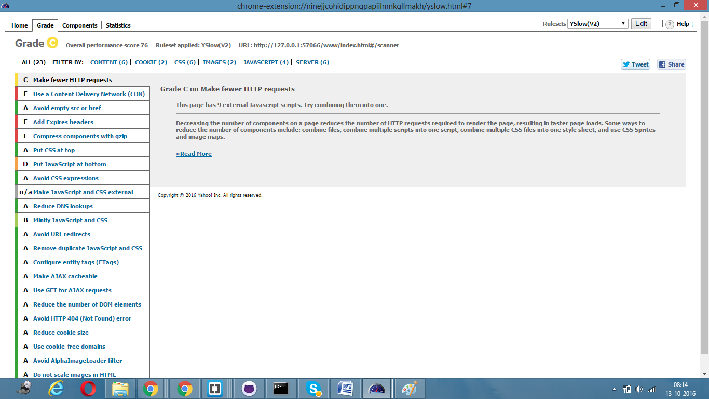



**Y-Slow Components:**

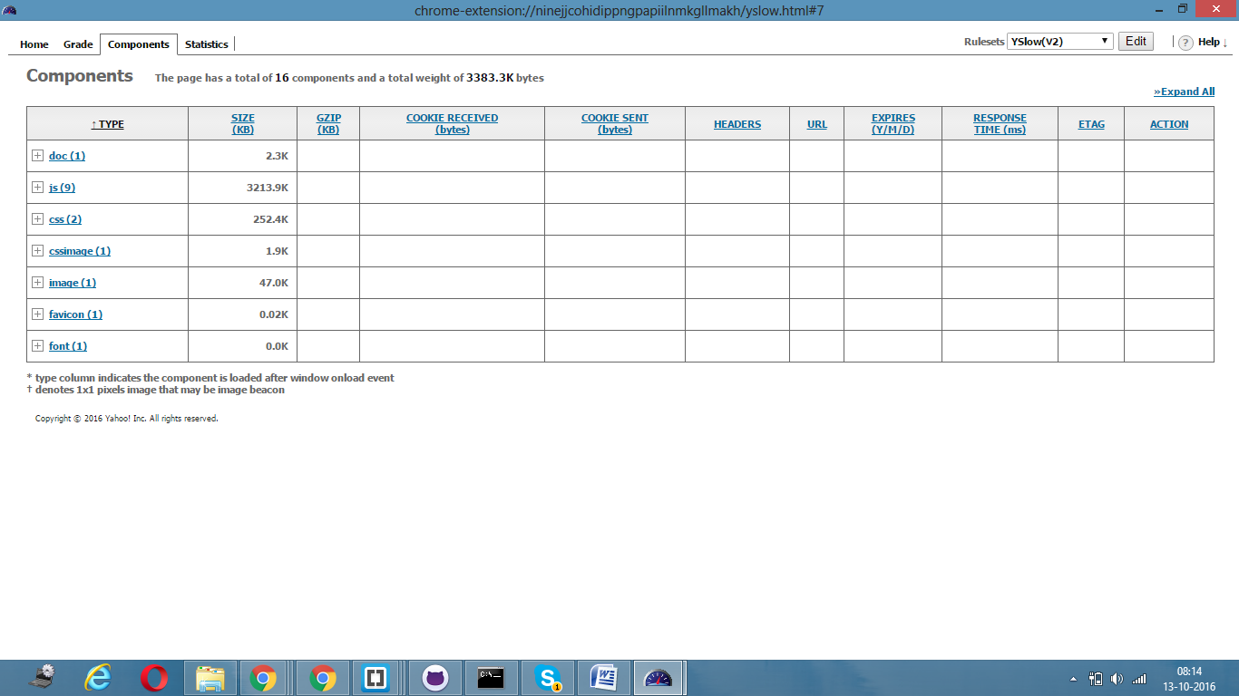

**Y-Slow Statistics:**

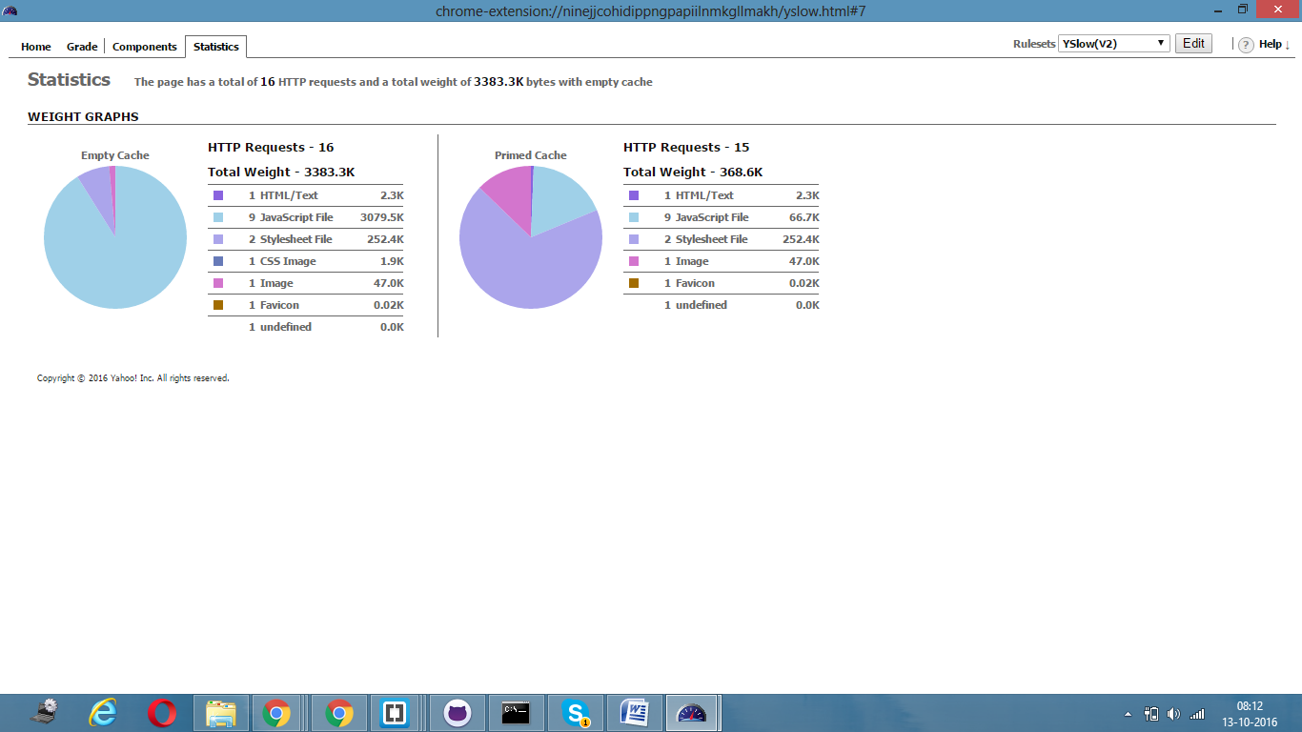

**Karma and Jasmine Test Cases:**

**TestCase 1:**

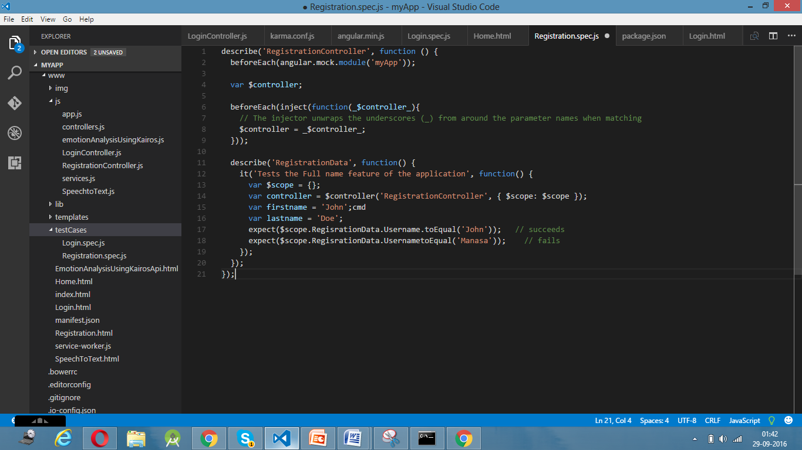

**TestCase 2:**

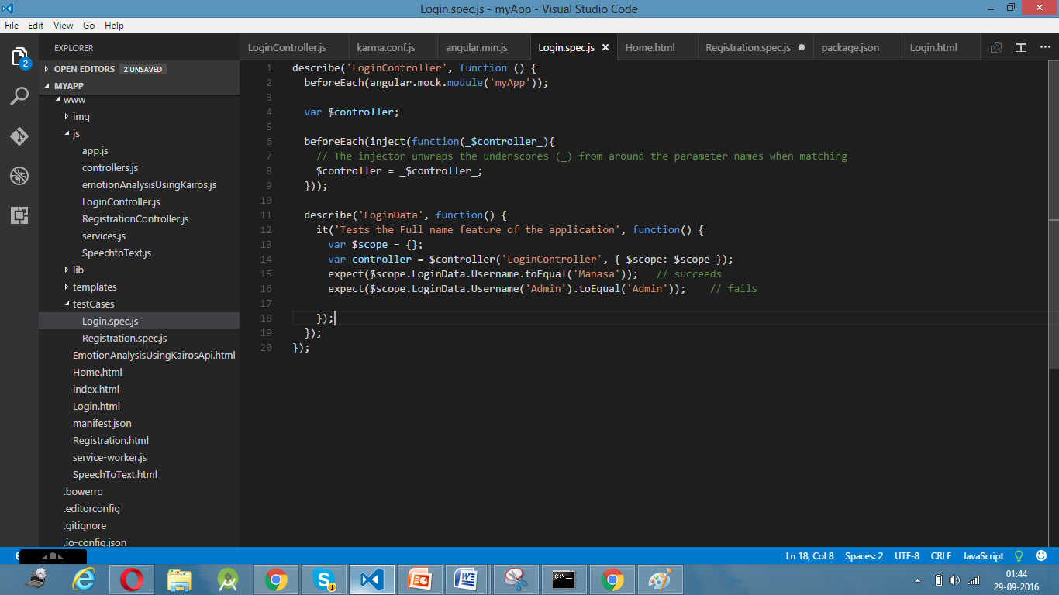

**TestCase 3:**

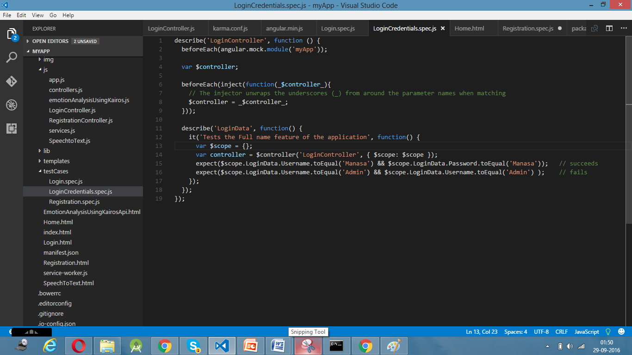

**TestCase Output:**